

|  |
| --- |
| Name:Syeda Rida Shahid Hackathon Day-5  Testing, Error Handling and backend integration |
|  |

|  |  |  |
| --- | --- | --- |
|  | |  |
|  |  | |
|  | | |
|  | | |

Hackathon Day 5

E-commerce Marketplace

Testing, Error Handling, and Backend Integration Refinement

Introduction:

Ensure "My Marketplace" is fully prepared for real-world deployment by carrying out extensive testing, fine-tuning performance metrics, and optimizing backend integrations. Focus on building a robust platform capable of handling high customer traffic seamlessly. Guarantee a smooth, intuitive, and error-free user experience to establish reliability and satisfaction among users.

Key Objective:

1. Testing:

1 .Validate all features and backend integrations related to product listings, customer management, and

Order processing.

2.Conduct functional, non-functional, and user acceptance testing to ensure smooth navigation and

reliable performance for furniture browsing and purchasing.

2. Error Handling:

1. Implement user-friendly error messages for issues like failed payments, unavailable products, or server errors.
2. Handle API errors gracefully with fallback UI elements to maintain a seamless user experience.

3. Performance Optimization:

1. Enhance the website's speed, responsiveness, and reliability, particularly for loading large images of

furniture items.

1. Perform performance testing to identify and fix bottlenecks, ensuring quick access to products like

sofas, chairs, and tables.

4. Cross-Browser and Device Compatibility:

1. Test the platform for flawless functionality across various browsers and devices, ensuring customers have

a consistent experience whether on mobile, tablet, or desktop.

5. Documentation:

1. Prepare professional testing reports (CSV-based) highlighting test results, identified issues, and resolutions.
2. Develop deployment-ready documentation, including best practices for maintaining and scaling the furniture e-commerce marketplace.

Step 1: Functional Testing

Ensure the marketplace's key features operate as intended, delivering a smooth and error-free user experience.

Key Features:

Product Listing:

Verify products are displayed accurately with proper details.

Product Details:

Ensure product detail pages show correct information like price, description, images, and availability.

Category Filters:

Test that filters return precise results based on user selection.

Dynamic Routing:

Validate seamless navigation to individual product detail pages.

Add to Cart:

Confirm items can be added, updated, and removed from the cart.

Add to Wishlist:

Ensure products can be added to and managed in the wishlist.

Responsive Design:

Validate that all features and pages adapt seamlessly to various screen sizes (mobile, tablet, and desktop).

User Profile Management:

Check that users can update personal information, view order history, and manage saved addresses.

Step 2: Error Handling

Implement robust error handling mechanisms to ensure a smooth user experience, even when issues arise, by displaying clear and user-friendly fallback messages.

Network Failure:

Display a meaningful error message when there are connectivity issues.

Example: "Unable to connect to the server. Please check your internet connection."

Invalid or Missing Data:

Handle cases where API responses return incomplete or invalid data.

Example: "Some information is missing. Please try again later."

Unexpected Server Errors:

Use generic fallback messages for unhandled server-side errors.

Example: "Something went wrong on our end. Please try again later."

API Error Handling:

Use try-catch blocks to gracefully manage API errors.

Step 3: Performance Optimization

Optimize the marketplace to improve load times, responsiveness, and overall performance. This step involves identifying bottlenecks and applying strategies to enhance the user experience.

**Key Areas :**

Optimize Media Assets

* **Image Compression:** Use tools like TinyPNG or ImageOptim to compress images, ensuring smaller file sizes without sacrificing quality.
* **Lazy Loading:** Load images and other assets only when they come into view, improving initial page load times.

Streamline Code

* **Minify Files:** Reduce the size of JavaScript (e.g., with Terser) and CSS (e.g., with CSSNano) to make loading faster.
* **Remove Unused Code:** Identify and eliminate any unnecessary CSS or JavaScript to keep files lightweight.

Improve Load Times with Caching

* **Browser Caching:** Store frequently used static files in the user's browser to reduce the need for repeated network requests.

Analyze Performance Tetsing:

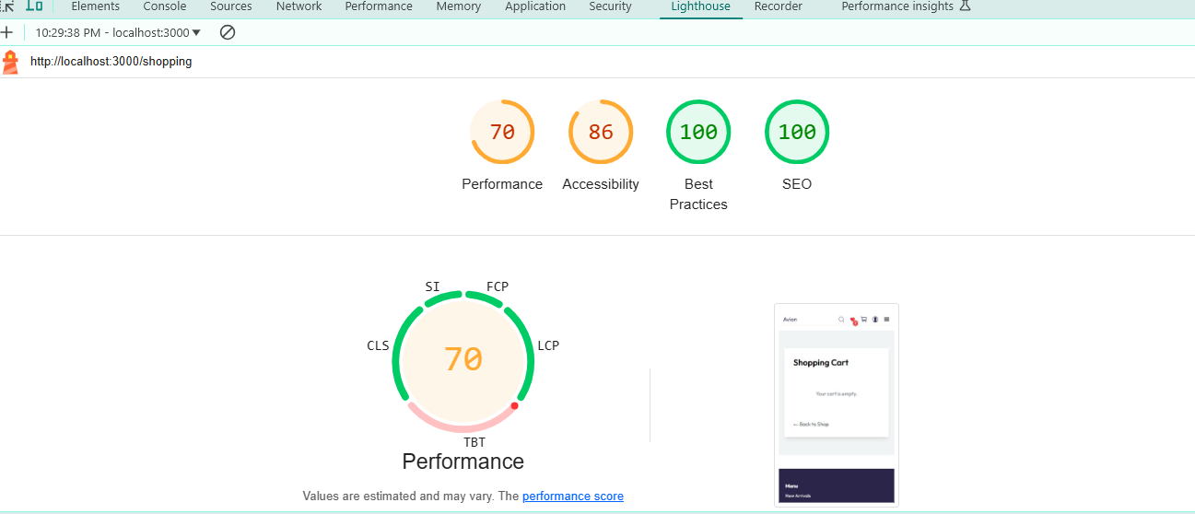

Step 5: Security Testing

Ensure the security of your marketplace by identifying vulnerabilities and implementing measures to protect sensitive data and prevent attacks.

Key Areas to Address

Input Validation:

Sanitize all user inputs to prevent SQL injection, cross-site scripting (XSS), and other injection attacks. Use regular expressions to validate fields like email addresses, phone numbers, and other critical inputs.

Secure API Communication:

Ensure all API calls are made over HTTPS to encrypt data in transit. Avoid exposing sensitive information, such as API keys, in the frontend code. Store them securely in environment variables.

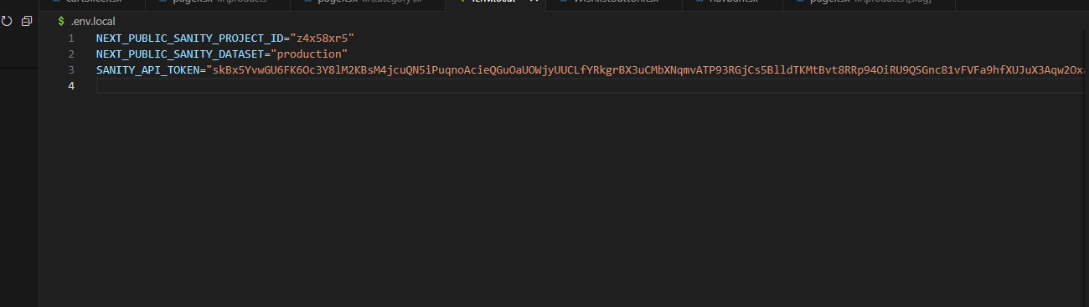

Authentication & Authorization:

Implement secure user authentication mechanisms like JWT (JSON Web Tokens) and OAuth. Ensure proper authorization checks are in place to restrict access to certain features or resources.

Cross-Site Request Forgery (CSRF) Protection:

Implement anti-CSRF tokens to prevent unauthorized actions from being executed on behalf of an authenticated user.

Step 6: User Acceptance Testing (UAT)

Ensure that the marketplace meets user expectations and provides a seamless, intuitive experience before final deployment.

Main Points:

**Simulate Real User Tasks**

* Perform everyday actions like browsing furniture categories, searching for specific items, adding products to the cart, and completing purchases to identify any usability issues and confirm that all features function correctly in real-world scenarios.

**Collect User Feedback**

* Invite peers, stakeholders, or potential customers to test the platform and share feedback. This will help uncover any pain points or areas that need improvement, ensuring the platform aligns with user expectations.

**Check User-Friendly Design**

* Test the interface to ensure it’s simple and easy to navigate. Validate workflows such as signing up, logging in, and placing orders to confirm they are smooth and error-free.

**Handle Special Scenarios**

* Test unusual scenarios, such as managing a large inventory, performing complex search queries, or simulating failed transactions and login attempts, to ensure the platform responds gracefully to edge cases.

**Test Compatibility Across Devices and Browsers**

* Ensure a consistent and seamless experience for users across various devices (desktop, mobile, tablet) and browsers (Chrome, Firefox, Safari, Edge). This guarantees accessibility for all users.

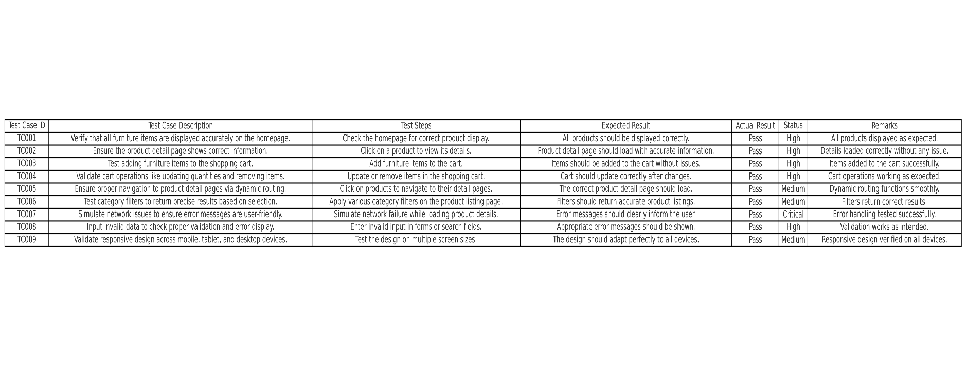

**Conclusion**  
Day 5 concentrated on finalizing the furniture marketplace platform for deployment, ensuring all features and components were rigorously tested, optimized, and polished. Key functionalities, such as product displays, cart management, category filtering, and dynamic routing, underwent extensive functional testing to guarantee seamless user experiences. Advanced error handling mechanisms, including user-friendly error messages and fallback designs, were implemented to boost reliability.

Performance optimization measures were carried out to enhance page load speeds and responsiveness, ensuring the platform adapts seamlessly across different devices and browsers. Detailed documentation was prepared, summarizing test results, resolutions, and best practices, ensuring the marketplace is fully equipped for a smooth and robust real-world launch

